[Requirements:](https://docs.hortonworks.com/HDPDocuments/CFM/CFM-1.0.0/installation/content/install-jdk.html)

<https://docs.hortonworks.com/HDPDocuments/CFM/CFM-1.0.0/installation/content/install-jdk.html>

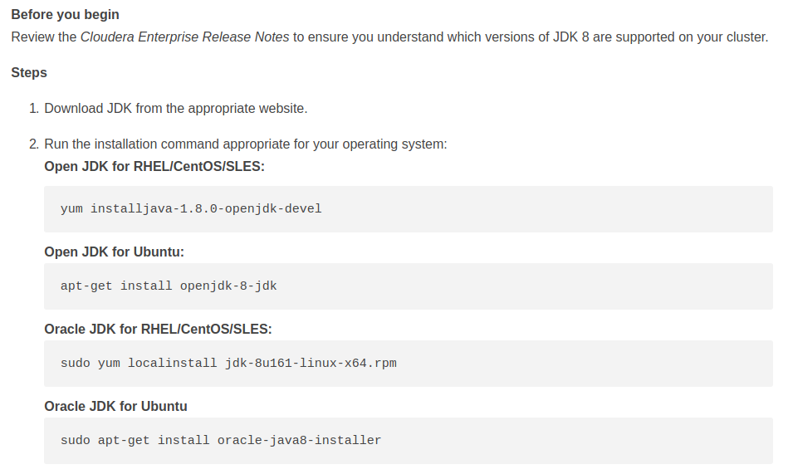

<https://www.cloudera.com/downloads/cdf.html>

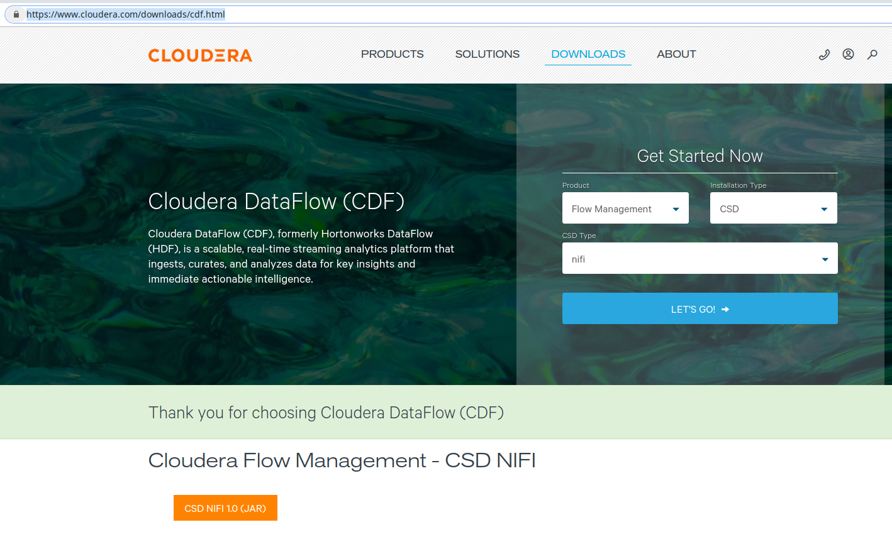

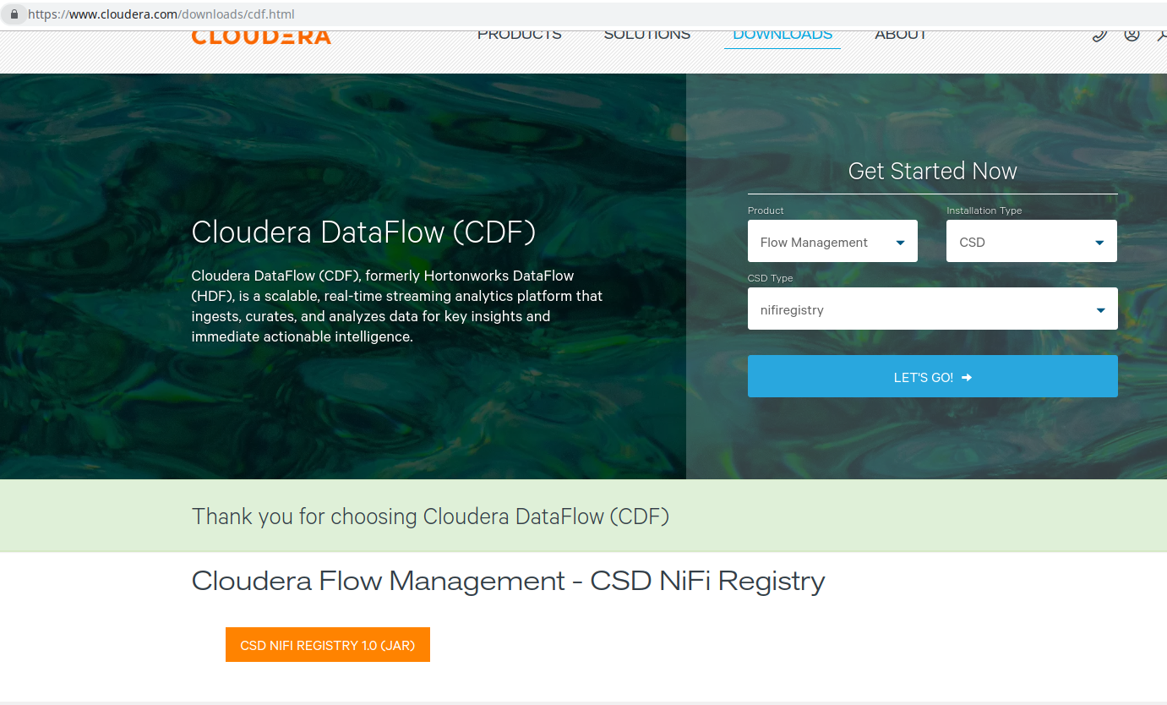

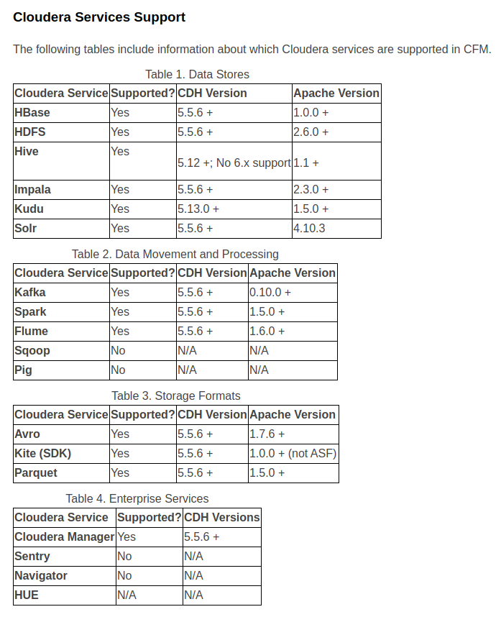

<https://docs.hortonworks.com/HDPDocuments/CFM/CFM-1.0.0/installation/content/manual-parcel-install.html>

http://archive.cloudera.com/CFM/parcels/1.0.0.0/CFM-1.0.0.0-el7.parcel

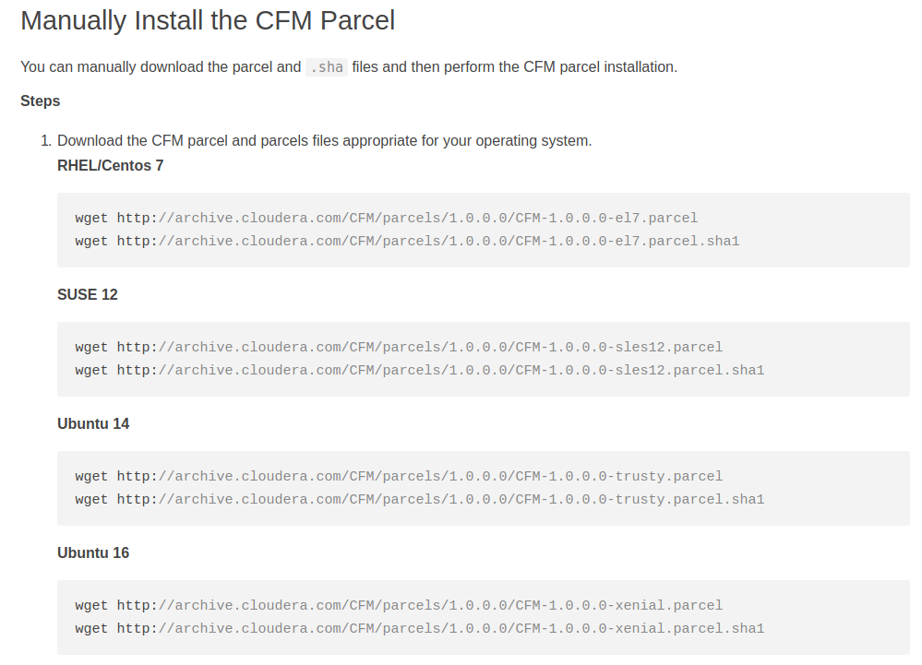

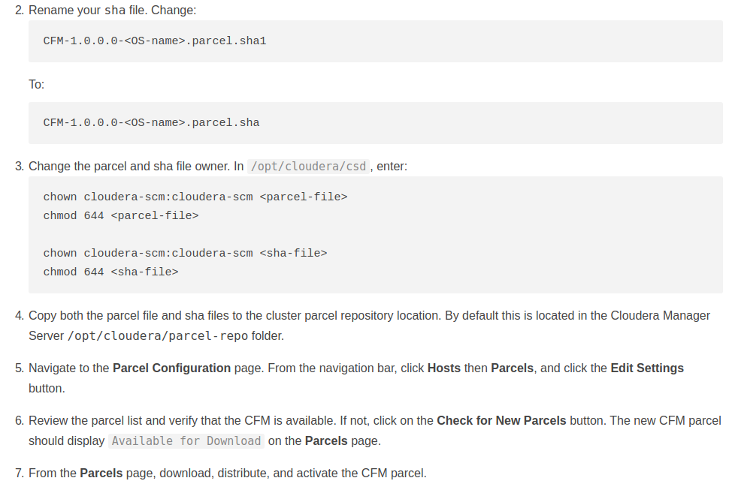

<https://docs.hortonworks.com/HDPDocuments/CFM/CFM-1.0.0/installation/content/get-csd.html>

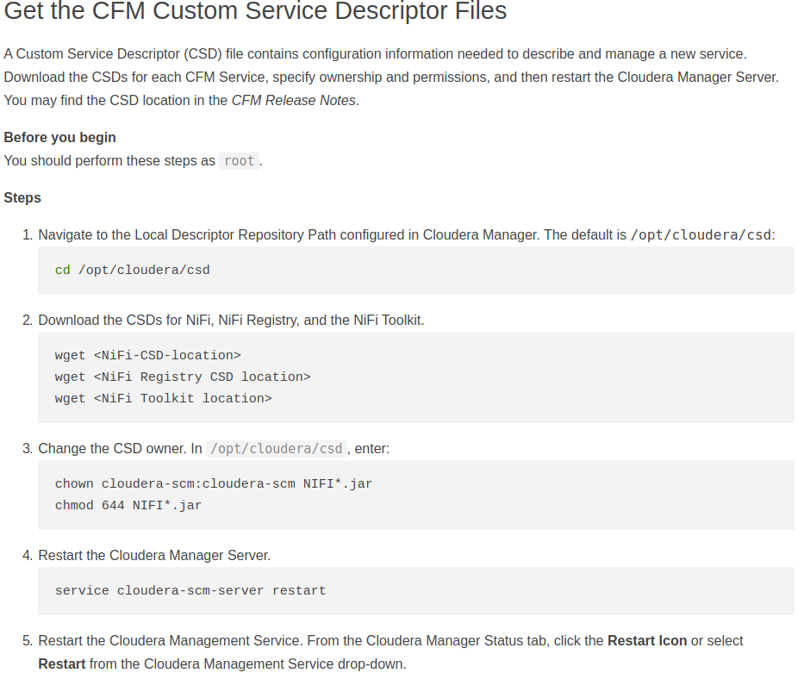

<https://docs.hortonworks.com/HDPDocuments/CFM/CFM-1.0.0/installation/content/add-nifi-service.html>

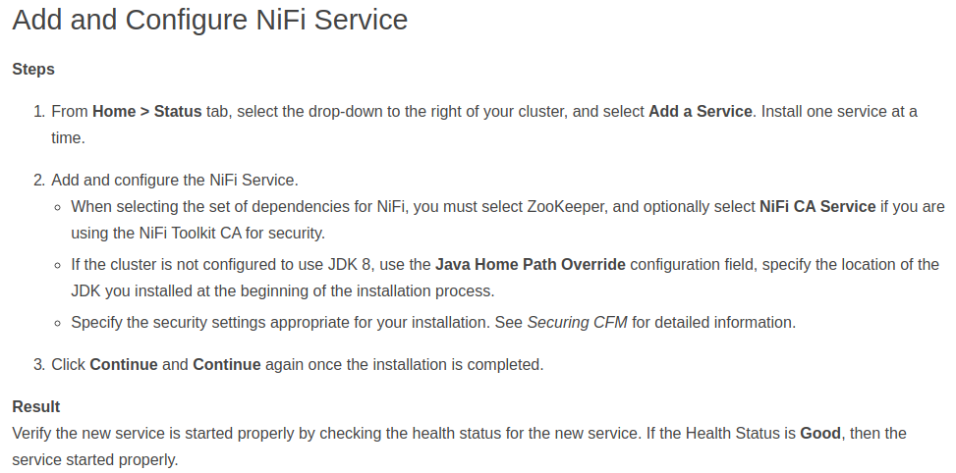

<https://docs.hortonworks.com/HDPDocuments/CFM/CFM-1.0.0/installation/content/add-nifi-registry-service.html>

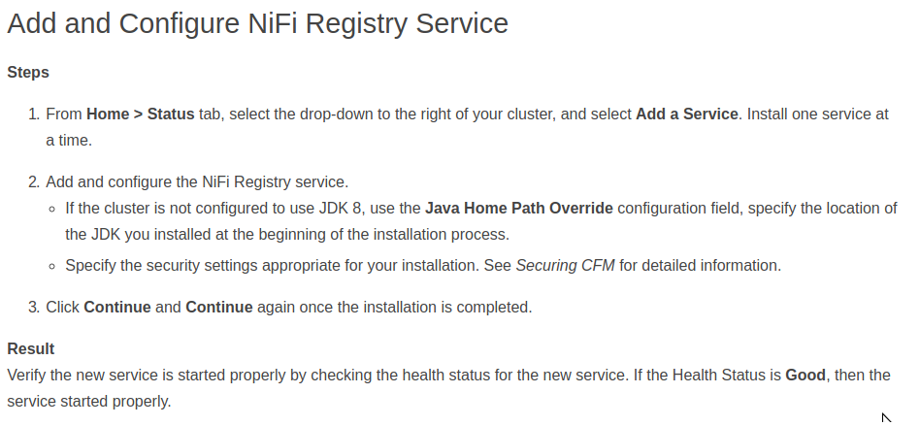

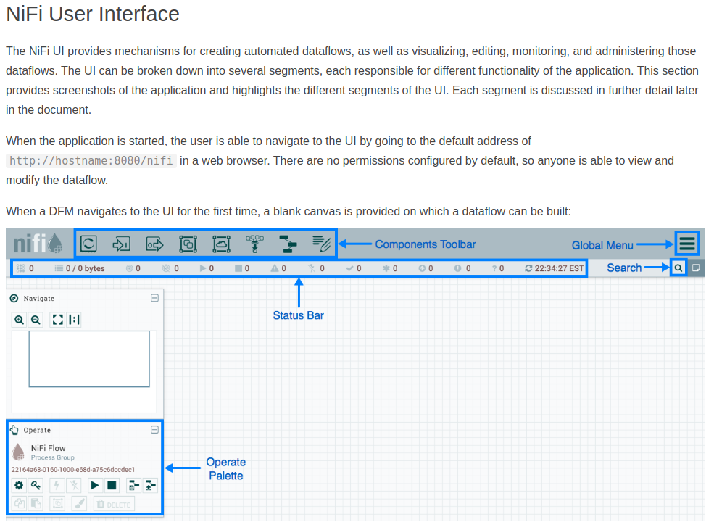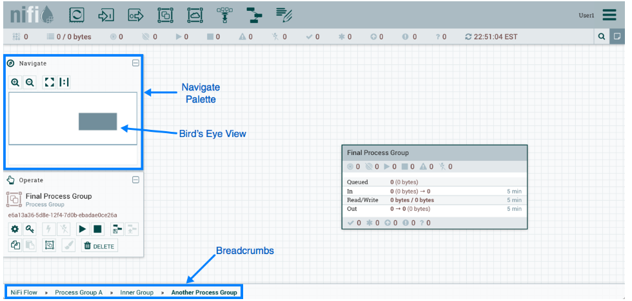

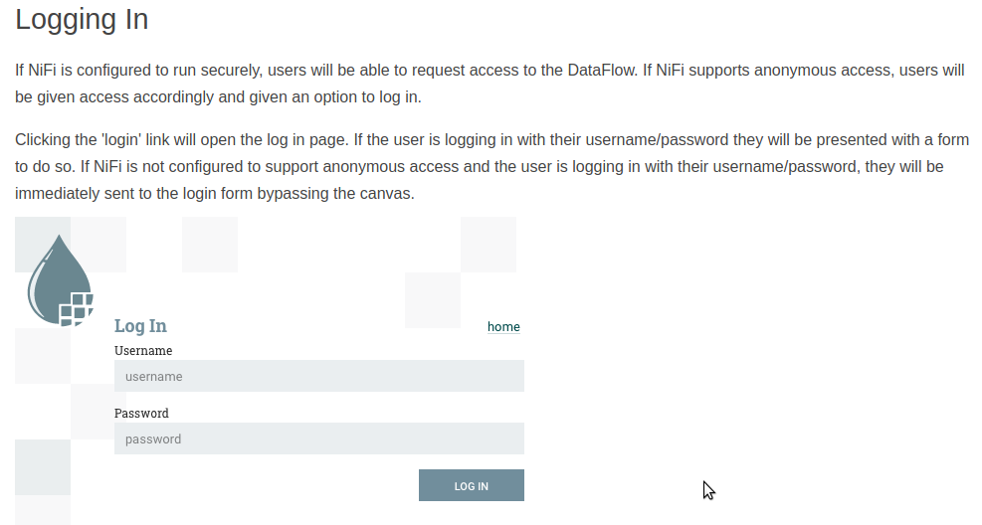

# NiFi Registry

<https://docs.hortonworks.com/HDPDocuments/HDF3/HDF-3.4.0/versioning-a-dataflow/content/connecting-to-a-nifi-registry.html>

